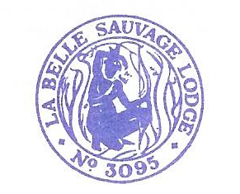
11 Clonmell Road
London
N17 6JY
07973 703372
29th December 2019

Bro Secretary

Dear Sir and Brother

Re Clearance Certificate for W Bro Philip John LGR

In accordance with Rule 175 of the United Grand Lodge of England Book of Constitutions, this certificate confirms that the above named Brother was a fully paid up member La Belle Sauvage Lodge No. 3095 until his resignation in May 2019, when he left in good standing and has no indebtedness to this Lodge .

W Bro Peter Allbut
Secretary
La Belle Sauvage Lodge 3095

