R. A. M. LODGE G.K. DEVARAJULU NO. 79
COIMBATORE
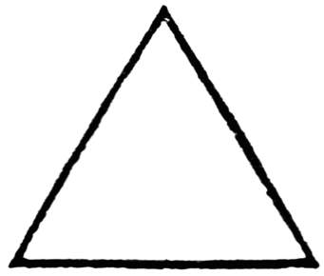

W. Bro. RM. Adaikalavan W. Bro. L. Rajesh W. Bro. J. S. Murugappan
W.C. N. Scribe Treasurer
-----------------------------------------------------------------------------------------------------------------------------
10 June 2019

NO DEMAND CERTIFICATE

We, the undersigned, do certify that,

W. BRO. MANI VALLATH MENON (W. Bro. MANI V MENON) (Sl. No. 2)

Whose Masonic Rank now is a ‘Past W.C.N’ in our Lodge

and who is still a subscribing Member of this Lodge, has

satisfied all demands against him and that he is in the

full enjoyment of all Masonic Privileges.

Given at Coimbatore

On the 10 day of JUNE 2019

W. Bro. J. S. Murugappan W. Bro. R. Sundar
Treasurer Asst. Scribe

R. A. M. LODGE G.K. DEVARAJULU NO. 79
COIMBATORE

W. Bro. RM. Adaikalavan W. Bro. L. Rajesh W. Bro. J. S. Murugappan
W.C. N. Scribe Treasurer
-----------------------------------------------------------------------------------------------------------------------------
20 July 2018

NO DEMAND CERTIFICATE

We, the undersigned, do certify that,

W. BRO. PULLANKATIL RAGHAVAN PRASAD (W. Bro. P.R. Prasad) (Sl. No. 45)

Whose Masonic Rank now is a ‘Imm. P.C.N’ in our Lodge

and who is still a subscribing Member of this Lodge, has

satisfied all demands against him and that he is in the

full enjoyment of all Masonic Privileges.

Given at Coimbatore

On the 20 day of JULY 2018

W. Bro. J. S. Murugappan W. Bro. L. Rajesh
Treasurer Scribe

