R. A. M. LODGE SATSANG No 165
Chennai
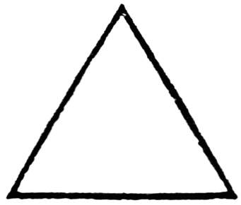

-----------------------------------------------------------------------------------------------------------------------------
20 July 2018

NO DEMAND CERTIFICATE

We, the undersigned, do certify that,

W. BRO. Puvaneshwaran Selvaganesh

Whose Masonic Rank now is a W.C.N in our Lodge

and who is still a subscribing Member of this Lodge, has

satisfied all demands against him and that he is in the

full enjoyment of all Masonic Privileges.

Given at Chennai

On the 20 day of JULY 2018

S.Srikanth

